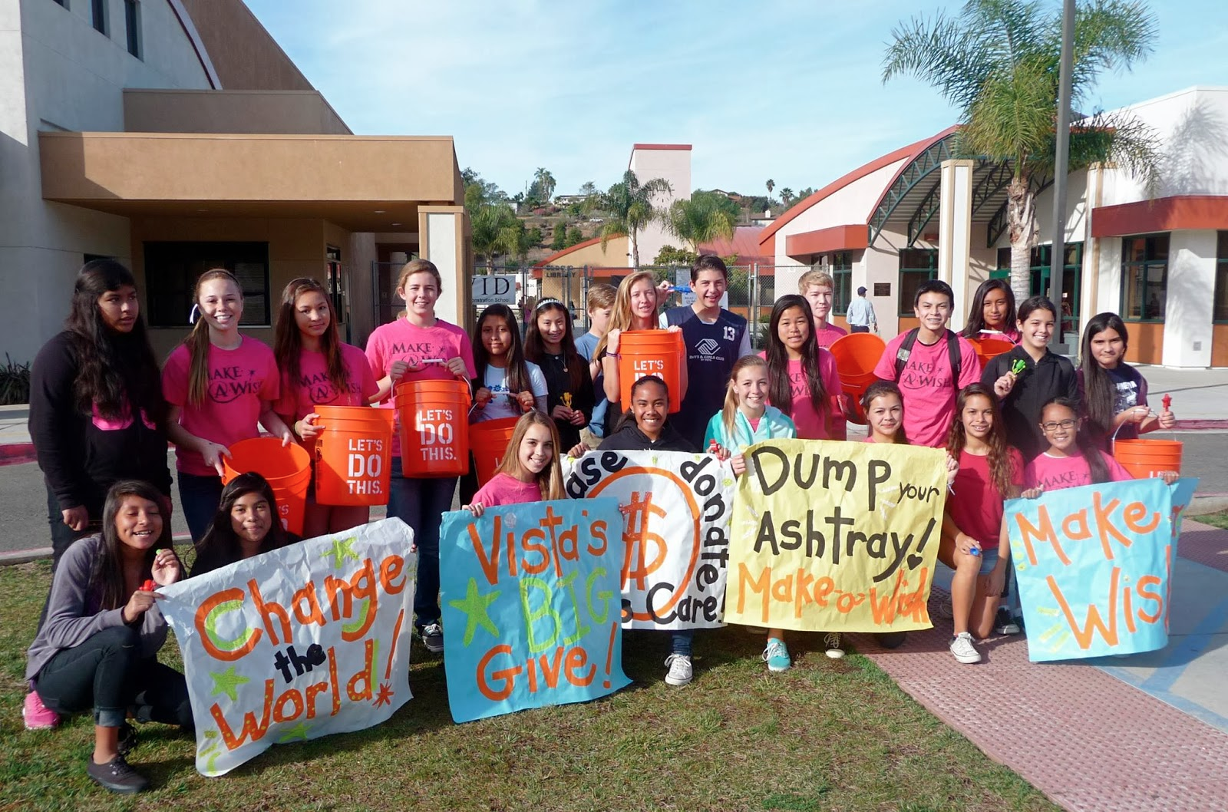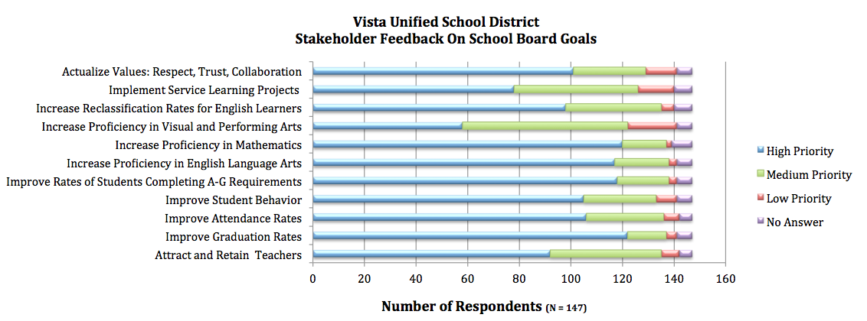

District Financial Brochure

2013-2014

**Vista Unified School District**

### Programs funded through VUSD that benefit students

**Regional Occupational Program (ROP)** provides career training in subjects such as: culinary arts, photography, digital art, engineering, automotive repair, first responder.

**Breaking Down the Walls** allows students to appreciate one another by understanding each other’s story

**Museum of Tolerance (MOT)** field trip to the MOT in Los Angeles to learn about the tolerance of others

**Every 15 Minutes** promotes safe and responsible driving to high school students

**21st Century Program** gives students a safe place to do meaningful and engaging activities after school

## *Rancho Minerva MS students supporting “Vista’s Big Give” Make a Wish Foundation*

## *Farm to Fork – Vista HS ROP students farming and preparing organic food*

**Vision**

Our vision in Vista Unified School District is to be the model of educational excellence and innovation.

**Mission**

The purpose of Vista Unified School District is to inspire each and every student to persevere as critical-thinking individuals who collaborate to solve real-world problems.

**Values**

* Respect: Treating all with dignity.
* Trust: Having confidence that every decision focuses on the best interests of all students.
* Collaboration: Working in a collective partnership with clear two-way dialogue that builds relationships among home, school and the community.

Devin Vodicka Ed.D

Superintendent of Schools

1234 Aracdia Ave   
Vista, CA 92084  
www.vistausd.org

Vista Unified School District

# **LCAP Priorities**

1. Basic Necessities – qualified and properly assigned teachers, sufficient instructional materials, facilities in good repair
2. Implementation of Common Core State Standards
3. Parental Involvement
4. Student Achievement – Statewide Assessments, API, EL Reclassification rate, College Preparedness
5. Student Engagement – Attendance rates, dropout rates, graduation rates
6. School Climate – Suspension and expulsion rates
7. Access to Courses – All students have access to rigorous course work by properly credentialed teachers
8. Other Student Outcomes in Subject Areas

For the 2013-2014 school year, the Vista Unified School District’s total budget is $185.3 million with a calculated average daily allowance (ADA) of $6,803.61per student. The current enrollment of the district is 22,125 students and has been in declining enrollment for at least the last 10 years. The average teacher salary within the district is $68,000 with an actual projected average teacher cost of $85,418.

Recent changes in California law have shifted the priorities when funding school districts. The Local Control Funding Formula (LCFF) shifts greater control to school districts to improve student achievement. To hold districts accountable for their funding decisions The Local Control Accountability Plan (LCAP) has been instituted to ensure that funding is spent wisely. Additional funds will be given to support English learners, foster care, and low-income students.

In order to successfully implement the district’s LCAP all of the district’s stakeholders (parents, students, staff, community members, local bargaining units, etc.) will be involved through a variety of methods which will include town-hall meetings, advisory committee updates, feedback sessions, School Board meeting presentations, website communications, and on-line surveys. The School Board of Education must approve the LCAP no later than June 30, 2014.

For further details on the future of funding for the district, please visit the district’s website at: *www.vistausd.org*

Total Expenditures = $185.3 million

Expenditures in millions of dollars

“I hope (through LCFF/LCAP) that VUSD will make a complete metamorphosis in how teaching and learning looks and feels like in the classroom.”

Matt Doyle, VUSD LCAP Project Lead